Energy Audit Report
For
Ikalto Kindergarten

Village Ikalto, Georgia
(Telavi Municipality, Georgia)
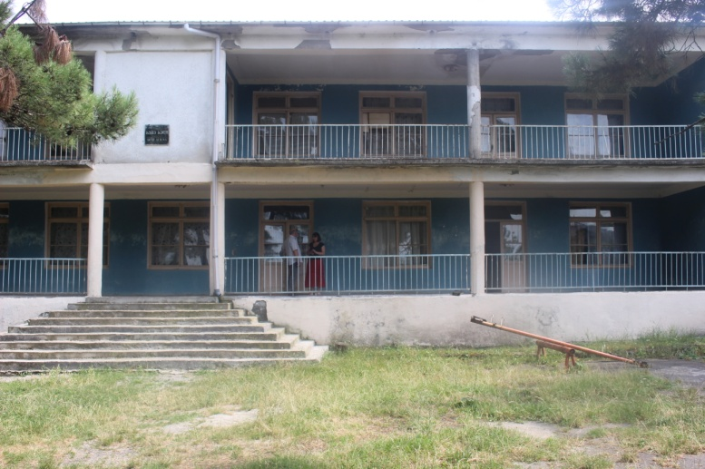

Energy Efficiency Centre Georgia

Tbilisi
2018

Contents
1 Summary 3
2 Introduction 4
2.1 Background 4
3 Project Organization 5
4 Building Description 5
4.1 General conditions 5
4.2 Heating system 8
4.3 Ventilation system 8
4.4 Domestic hot water system 8
4.5 Fans and pumps 9
4.6 Lighting system 9
4.7 Various 9
4.8 Cooling 9
5 Energy Consumption 10
5.1 Measured energy consumption 10
5.2 Calculated and baseline energy consumption 11
6 Energy efficiency measures 12
6.1 List of measures 12
6.2 Measures 13
9. Ecological Benefits 17
Implementation schedule 17

Summary
The total baseline energy consumption of Ikalto kindergarten amounts 231,406 kWh/year that ensures normal operating condition of the building; Out of which approximately223,012 kWh/year is needed for space heating and8,394 kWh/year for various appliances(including: refrigerators, TV, lighting and kitchen equipment, el. water heaters, stoves and etc.)
The energy savings potential of identified energy efficiency and retrofit measures are summarised in the following table:
EE Potential - Energy Audit
Kindergarten of Ikalto |  |  |  | Conditioned area: 908 m²
EE measures |  | Investment  [EUR] |  | Net savings  [kWh/y] | Payback period  [y]
1. | Thermal insulation of roof | 15,990 |  | 64,676 | 12.4
2. | Thermal insulation of floor | 13,325 |  | 51,023 | 13.1
3. | Replacement of incandescent bulbs with LED luminaries | 2,125 |  | 1,598 | 21.1
4. | Installation of solar water heating system | 3,000 |  | 4,701 | 25.5
5. | Installation of PVC windows | 39,150 |  | 63,336 | 30.9
6. | Thermal insulation of wall | 22,050 |  | 24,530 | 44.9
7. | Installation of central heating system | 18,000 |  | - | -
8. | Installation of ventilation system | 25,110 |  | - | -
TOTAL |  |  | 138,750 | 209,865 | 22.3
The figures have an accuracy of ± 10-15%.

Introduction

Background
The kindergarten is located in the village Ikalto. The 2-storeid building was constructed at 1969 year. The most recent repair/reconstruction of the building was held in 1971. The Total area of the building is about 908m². The building is connected to cold water supply and sewage systems, also to electricity and natural gas supply.
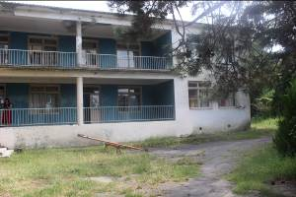
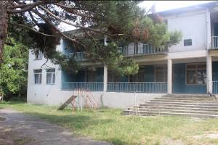
Building envelope: The building basically has old wooden frame windows with single glazing and old wooden doors in poor condition; also about 30% from total windows is PVC framed windows with double-glazing in not bad condition. The sloped roof with unheated attic space is covered with tin plates. The contraction material used for the building outside wall is clay bricks with thickness 40cm. The small part of external wall of building includes concrete blocks with thickness 20cm, which is also source of heat losses.

The ground floor of concrete slab from inside is cover mainly with wooden parquet in bad condition. The floor of the entrances and kitchen/toilets is paved with ceramic plates. From the outside ground floor without thermal insulation has unheated space which is source of the heat losses.
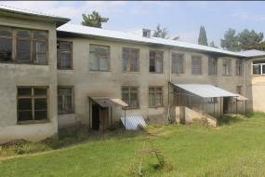
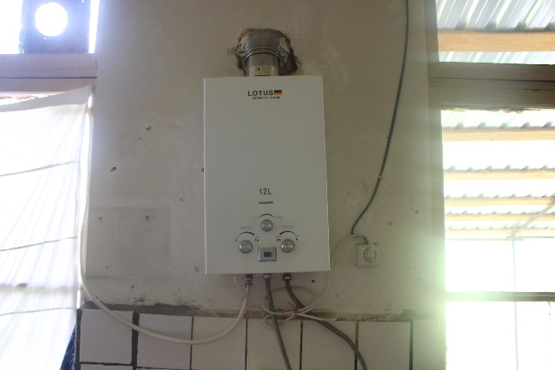
For the space heating of the building is used 7 wood stoves which is not enough to heat up the total building area and achieve minimum comfort condition. For the hot water preparation the kindergarten is using 1 unit natural gas water heater with capacity 12L/m. It should be mentioned that currently the building has about 40% of total building space that is in poor condition and is not heated and which needs renovation and optimization of heating system, in order to achieve minimum comfort levels in whole building.

The kindergarten is equipped with following household electric appliances: DVD player, refrigerators, el. kettle, TV sets, Audio devices, meat machine.
The building rooms are lighted with incandescent (45 unites) light bulbs. Partially the bulbs in the rooms don’t work, so it has to be repaired and/or replaced as well as renovated.
In overall average indoor temperature in the building is less than comfort level and has critical thermal losses from roof, floor, walls and windows which have to be insulated. Also it is necessary to install central heating system for total building.
Also absence of ventilation system causes oxygen deficit. In order to refresh indoor air quality workers/staff regularly are opening windows, which are the sources of heat losses.
The approximate results of assessment and evaluation of these measures are given in this report.
The aim of the project is to improve indoor environment and reduce electricity, natural gas and water consumption, as well as CO₂ emissions.In order toimprove existing condition of the building, based on energy audit calculations it was sudgested the following EE Measures:
- Thermal insulation of roof;
- Thermal insulation of floor;
- Replacement of incandescent bulbs with LED luminaries;
- Installation of solar water heating system;
- Installation of PVC windows;
- Thermal insulation of wall;
- Installation of central heating system;
- Installation of ventilation system.

Project Organization
Name of Project/Building/Site: | Ikalto Kindergarten
Address: | Village Ikalto,Telavi
Contact person: | Mrs. Nino Botkoveli – Director
Phone: | (+995 ) 551557017(mobile cell)
Building owner: | Telavi Municipality
Implementer of Energy Audit | Union Energy Efficiency Centre Georgia (EECG)
Contact person: | Mr. George Abulashvili
Address: | # 19 D. Gamrekeli Str, OFFICE # 611; Tbilisi 0160, Georgia
Phone: | +995 32 224 25 42
Role in the project: | Director of EECG
Energy Auditor: | Mr. Konstantine Barjadze –EECG
Phone: | +995 32 224 25 42
Role in the project: | Technical Expert

Building Description

General conditions
Type of building |  | Kindergarten
Year of construction |  | 1969 |  |  | In regular operation since (year) |  |  |  | 1971
Number of occupants
Permanent inhabitants/staff |  |  | 100/21 |  |  |  | persons
Average indoor temperatures
Condition |  |  |  |  |  | Norms
Temp. when heated | 15.5 |  |  | °С |  | Temp. when heated |  | 21 |  | °C
Temp. when setback | 8.0 |  |  | °С |  | Temp. when setback |  | 18 |  | °С
Installed meters
In the building there are electricity, natural gas and cold water meters.

Building data
Conditioned area | 908 | m²
Conditioned volume | 2,633 | m³
Floor area | 533 | m²
Height of floor | 2.9 | m
Number of floors | 2

External walls
General evaluation of the condition of the walls |  |  |  | Acceptable
Total area external walls |  | 371 |  | m² | U-value (average) |  | 1.13 | W/m²K
Orientation | N | NE | E | SE | S | SW | W | NW
Wall area, m² | 142 |  | 88.74 |  | 232 |  | 88.74
Material type | Brick |  | Brick and concrete block |  | Brick and concrete block |  | Brick and concrete block
Insulation type | - |  | - |  | - |  | -
U value, W/m²K | 1.07 |  | 1.07-1.87 |  | 1.07-1.87 |  | 1.07-1.87
Material type | Brick walls with thickness δ= 0.40m, U=1.07W/m²K  Concrete block walls with thickness δ= 0.20m, U=1.87W/m²K
Insulation type 1 | n/a

Windows
General evaluation of the condition of windows |  |  |  |  | Old wooden framed single glazing windows in poor condition/ 30% PVC windows in good condition
Total area windows |  |  |  | 241.4 | m² | U value (average) | 4.56 | W/m²K
Orientation | Material¹ | Type ² | Size A x B | Area | Q-ty | g | U value  W/m²K
 |  |  | m | m² | n
N | W  P | 1G  2G | 1.87x1.90  1.87x1.90 | 60.35  14.2 | 17  4 | 0.56  0.56 | 5.00  3.00
E | W  P | 1G  2G | 1.87x1.90  1.87x1.90 | 24.85  14.2 | 7  4 | 0.56  0.56 | 5.00  3.00
S | W  P | 1G  2G | 1.87x1.90  1.87x1.90 | 71  14.2 | 20  4 | 0.56  0.56 | 5.00  3.00
W | W  P | 1G  2G | 1.87x1.90  1.87x1.90 | 28.4  14.2 | 8  4 | 0.56  0.56 | 5.00  3.00
Total |  |  |  | 241.4 | 68 |  | 4.56
Material ¹ |  |  |  | Wood (W), Aluminium (Al),Plastic (P),Steel (St)
Type ² |  |  |  | Single-frame (S), Double-frame (D), Bonded frame (B),  Single glazed (1G),Double glazed (2G), Triple glazed (3G)

Doors
General evaluation of the condition of doors |  |  |  |  | Single glazed doors with single-frame wood in poor condition
Total area doors |  |  |  | 29.4 | m² | U value (average) | 4.56 | W/m²K
Orientation | Material¹ | Type ² | Size A x B | Area | Q-ty | g | U value  W/m²K
 |  |  | m | m² | n
N | W | 1G | 2.57x1.50 | 15.44 | 4 | 0.4 | 5.0
E | W | S | 2.60x0.90 | 2.34 | 1 | 0.1 | 4.0
S | W | S | 2.10x1.47 | 9.27 | 3 | 0.2 | 5.0
W | W | S | 2.60x0.90 | 2.34 | 1 | 0.1 | 4.0
Total |  |  |  | 29.4 | 9 |  | 4.56
Material ¹ |  |  |  | Wood (W), Aluminium (Al), Plastic (P), Steel (St)
Type ² |  |  |  | Single-frame (S), Double-frame (D), Bonded frame (B),  Single glazed (1G), Double glazed (2G), Triple glazed (3G)

Roof
General evaluation of the condition of the roof |  |  | Good
Total roof area | 533 |  | m² | U value (average) |  | 2.19 | m²K/W
Roof type | Material type | Insulation type | Insul. thickn.  m | Slab thickn.  m | Area  m² |  | U  W/m²K
Sloped with unheated attic space | Concrete Slab | - | - | 0.2 | 533 |  | 2.19
Material type | Roof of concrete slab (thickness δ= 0,2m) with unheated attic space covered with tinplate,  U=2.19W/m²K
Insulation type | n/a

Floor
General evaluation of the condition of the floor |  | Acceptable
Total floor area | 533 | m² | U value (average) | 1.87 | W/m²K
Type of floor | Floor of concrete slab (thickness δ= 0,2m) with unheated space below  U=1.87W/m²K
Floor construction materials | Reinforced concrete slab, cement mortar, wooden floor

Heating system
For the space heating building is using 7 wood stoves which are not enough to heat up the total building area and achieve minimum comfort condition. It should be mentioned that currently the building has about 40% of total building space unheated in poor condition which needs renovation and optimization of heating system, in order to achieve minimum comfort levels in whole building.

Ventilation system
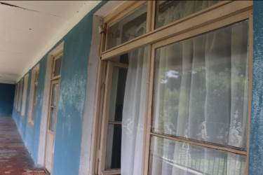
Considering that kindergarten has no active ventilation system, it causes oxygen deficit. In order to refresh indoor air quality workers/staff regularly are opening windows, which are the sources of heat losses.

It’s recommended to install automatic ventilation system which will minimize heat losses from the windows.

Domestic hot water system
For the hot water preparation kindergarten is using one natural gas water heater with capacity 12L/m.

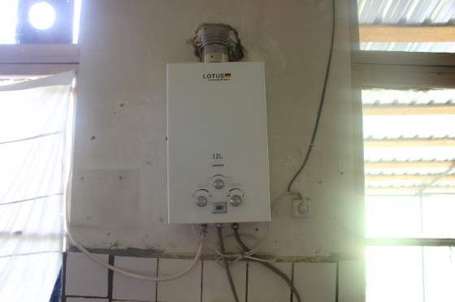
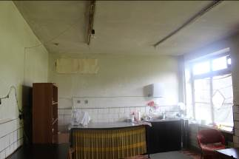

Fans and pumps
There aren’t fans and/or pumps in the building.

Lighting system
Luminaries | Quantity  pcs | Installed capacity  kW | Average power  W/m² | Type of control / comments
Incandescent | 45 | 4.5 | 4.96
CFL | 0 | 0 | 0
Total | 45 | 3.1 | 4.96

Lighting
Average power demand | 5.0 | W/m²
Operation period | 10 | h/week

Various
Various exploitable | Quantity  pcs | Installed capacity  kW | Average power  W/m² | Comments
TV | 1 | 0.08 | 0.04
Refrigerator | 2 | 3.0 | 0.66
Audio device | 1 | 0.1 | 0.02
DVD | 1 | 0.05 | 0.01
Meat machine | 2 | 1.6 | 0.18
Total | 8 | 4.83 | 0.91

Cooling
There is no cooling system in the building.

Energy Consumption

Measured energy consumption
The following table shows the measured energy consumption and its costs in the building during the last year, before implementation of energy efficiency measures:
Year 2015 | District heating | Electricity | N. Gas | Wood | Total
Energy costs | - | 0.063€ | 0.025€ | 0.02€ | 648 | EUR
Energy consumption | - | 682 | 205  (21m³) | 72,000  (36m³) | 72,887 | kWh
Specific consumption | - | 0.8 | 0.2 | 79.3 | 80.3 | kWh/m²
Water consumption | -m³ | / - EUR |  | - | EUR/y

Year 2016 | District heating | Electricity | N. Gas | Wood | Total
Energy costs | - | 0.063€ | 0.025€ | 0.02€ | 740 | EUR
Energy consumption | - | 968 | 1,798  (184m³) | 72,000  (36m³) | 74,766 | kWh
Specific consumption | - | 1.1 | 2.0 | 79.3 | 82.4 | kWh/m²
Water consumption | -m³ | / - EUR |  | - | EUR/y

Year 2017 | District heating | Electricity | N. Gas | Wood | Total
Energy costs | - | 0.063€ | 0.025€ | 0.02€ | 813 | EUR
Energy consumption | - | 1,158 | 5,442  (557m³) | 72,000  (36m³) | 78,600 | kWh
Specific consumption | - | 1.3 | 6.0 | 79.3 | 86.6 | kWh/m²
Water consumption | -m³ | / - EUR |  | - | EUR/y

Average of 2015/16/17 | District heating | Electricity | N. Gas | Wood | Total
Energy costs | - | 0.063€ | 0.025€ | 0.02€ | 734 | EUR
Energy consumption | - | 936 | 2,911  (298m³) | 72,000  (36m³) | 75,847 | kWh
Specific consumption | - | 1.0 | 3.2 | 79.3 | 83.5 | kWh/m²
Water consumption | -m³ | / - EUR |  | - | GEL/y

Calculated and baseline energy consumption
Energy Budget
The calculation is made by ENSI (Energy Saving International - Norway) Software Programme.
The climatic data used for calculations are shown on table below:
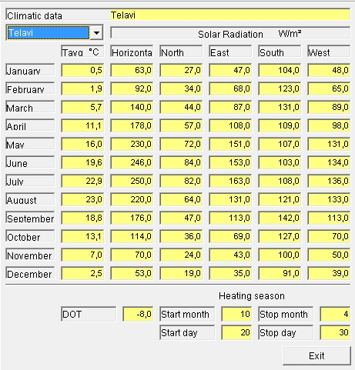
The calculated and measured energy consumption before and after implementation of energy efficiency and renovation measures is summarised in the following Energy Budget.
Energy Budget - Energy Audit
Budget Item | Standard | Before EE  Actual | Before EE  Baseline | After retrofit EE measures
 | [kWh/m²] | [kWh/year] | [kWh/year] | [kWh/year]
Heating | 45.7 | 71,519 | 223,012 | 19,446
Ventilation | 25.2 | 0 | 0 | 0
DHW | 39.9 | 5,597 | 5,597 | 896
Fans/pumps | 5.3 | 0 | 0 | 0
Lighting | 7.7 | 400 | 1,998 | 400
Various | 3.4 | 799 | 799 | 799
Cooling | 0.0 | 0 | 0 | 0
Total | 127.3 | 78,314 | 231,406 | 21,541

The total baseline energy consumption of Ikalto kindergarten amounts 231,406 kWh/year that ensures normal operating condition of the building; Out of which approximately223,012 kWh/year is needed for space heating and8,394 kWh/year for various appliances (including: refrigerators, TV, lighting and kitchen equipment, el. water heaters, stoves and etc.)
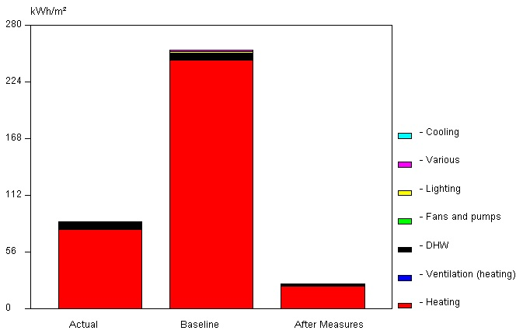Energy budjet was calculated by using ENSI (Energy Saving International, Norway) Software Program.

Energy efficiency measures

List of measures
The following EE and renovation measures are evaluated and described in detail in the following chapters. Table with information for each measure is presented separately.
List of retrofit measures is provided below:
- Thermal insulation of roof;
- Thermal insulation of floor;
- Replacement of incandescent bulbs with LED luminaries;
- Installation of solar water heating system;
- Installation of PVC windows;
- Thermal insulation of wall;
- Installation of central heating system;
- Installation of ventilation system.
Description of all measures that have been evaluated is given below:

Measures
Measure 1: | Thermal insulation of roof
Existing situation
The concrete slab (with thickness 20 cm) of the building ceiling has sloped roof with unheated attic space, which is covered with tin plates and needs thermal insulation. The average heat conductivity value is U=2.19W/m²K
Description of measure
To decrease heat losses from the roof it is recommended to insulate building horizontal ceiling with 20cm of Rockwool bat covered with vapour membrane. After insulation the average heat conductivity value will decrease to U=0.16W/m²K
Total area of roof (including balcony) is 533m².
Price of 1m²Rockwoolbat with thickness 20cm is about 8€, price for vapour membrane and other supporting materials for 1m² is about 2€, Price for installation and transport 20€ per 1m². So total cost for per square metre 20cm insulation will be:
8€+2€+20€=30€
Total cost of roof insulation will be:
533m² x 30€ = 15,990€
It has to be considered that existing building has no lightning protection and rainwater system, which is necessary and important to maintain building construction and insulation materials safe. Installation costs of rainwater and lightning protection system are not included in insulation costs.
After implementation of recommended measure building annually will save 64,676kWh/y and correspondingly 1,294€.
Investment: |  | 15,990 | EUR
Net savings |  | 64,676 | kWh/y
Cost savings |  | 1,294 | EUR
Useful lifetime |  | 20 | Years

Measure 2: | Thermal insulation of floor
Existing situation
The ground floor of concrete slab (with thickness 20cm) from inside is cover mainly with wooden parquet in bad condition. The floor of the entrances and kitchen/toilets is paved with ceramic plates. From the outside ground floor without thermal insulation has unheated space (basement) which is also source of the heat losses. The average heat conductivity value is U=1.87W/m²K
Description of measure
To decrease heat losses from the ground floor it is recommended to insulate ground concrete slab from outside (ceiling of basement) with 10cm EPS (expanded polystyrene foam) boards. After insulation the average heat conductivity value will decrease to U=0.27W/m²K
Total area of floor (including balcony) is 533m²
Price of 1m² EPS (thickness 10cm) is about 3€, price for other supporting materials for 1m² is about 2€, Price for installation and transport 20€ per 1m². So total cost for per square metre 20cm insulation will be:
3€+2€+20€=25€
Total cost of roof insulation will be:
533m² x 25€ = 13,325€
After implementation of recommended measure building annually will save 51,023kWh/y and correspondingly 1,020€.
Investment: |  | 13,325 | EUR
Net savings |  | 51,023 | kWh/y
Cost savings |  | 1,020 | EUR
Useful lifetime |  | 20 | Years

Measure 3: | Replacement of incandescent bulbs with LED luminaries
Existing situation
The building lighting system includes 45 units of 100W incandescent bulbs, which total capacity is not enough to light up the total building with minimum level of standard.
Description of measure
In order to decrease power consumption for lighting comparing to designed baseline consumption, it is recommended to replace existing bulbs and additionally install sufficient capacity (about 12Watts each) LED luminaries with total quantity 85. Also renovation of existing power supply system in the building.
Approximate price for replacement of each luminary is about 25€ (including updating works of existing power supply system if needed). So approximate total cost for the lighting system renovation will be:
25€ x 85 = 2,125€
After implementation of recommended measure building annually will save 1,598kWh/y and correspondingly 101€.
Investment: |  | 2,125 | EUR
Net savings |  | 1,598 | kWh/y
Cost savings |  | 101 | EUR
Useful lifetime |  | 30,000 | Hours

Measure 4: |  |  | Installation of solar water heating system
Existing situation
Currently the kindergarten for the hot water preparation is using one natural gas water heater with capacity 12L/m.
Description of measure
Considering number of beneficiaries (100/21) and annual gas consumption about557m³(5,000kWh) on hot water preparation is required for kitchen, the ideal capacity of solar water heating system (which will annually convert nearly the same amount of solar energy to thermal energy) is about 200L to optimally replace natural gas water heater. It should be mentioned that oversizing of capacity of solar water heating system in summer holiday period (when kindergarten has no need of hot water) can increase the hot water consumption and decrease the lifetime of heating system.
In order to decrease energy consumption for hot water preparation It is recommended install (integrated with central heating system) on the roof solar water heating system panel withhot water tank capacity 200L, which will annually convert 4,701 kWh/y solar energy to thermal energy, correspondingly will save same amount of energy and decrease bills for natural gas by 118€.
Base on local market average prices provided by local companies, approximate price of (made in Europe) solar water heating system with capacity of 200L is about 3,000€ including installation works.
Investment: |  |  |  | 3,000 | EUR
Net savings |  |  |  | 4,701 | kWh/y
Cost savings |  |  |  | 118 | EUR
Useful lifetime |  |  |  | 20 | years

Measure 5: | Installation of PVC windows
Existing situation
The building basically has old wooden frame windows with single glazing (U=5.0W/m²K) and old wooden doors (U=4.0W/m²K)in poor condition; also about 30% from total windows is PVC framed windows with double-glazing in not bad condition (with small gaps of air infiltration between frame and wall).
Description of measure
To decrease heat losses from the existing windows, it is recommended to replace existing old wooden framed single glazing windows and standard PVC framed double glazing windows (U=3.0W/m²K) with, triple-glazing PVC framed windows with advanced coating (U=1.2W/m²K). Also it is recommended to replace existing old wooden doors with PVC doors (U=1.5W/m²K).
Total area of the wooden framed windows is about 241m² and doors 30m²
Price of 1m²installation of new PVC frame triple-glazed windows is approximately 150€
Price of 1m²installation of new PVC framed doors is approximately 100€
So total cost for renovation will be:
241 x 150€ + 30 x 100€= 39,150€
After implementation of recommended measure building annually will save 63,336kWh/y and correspondingly 1,267€.
Investment: |  | 39,150 | EUR
Net savings |  | 63,336 | kWh/y
Cost savings |  | 1,267 | EUR
Useful lifetime |  | 20 | Years

Measure 6: | Thermal insulation of wall
Existing situation
The building walls basically are constructed with 40 cm clay bricks without thermal insulation (U=1.07W/m²K), some small part of the external wall includes concrete blocks with thickness 20cm (U=1.81W/m²K), so it would be better to insulate them to avoid the extra heat losses.
Description of measure
To decrease heat losses from the building external walls it is recommended to insulate them with 15cm Rockwool bat boards from outside and cover will all necessary construction protective and hydro insulation layers (including anchors, armoured net, plaster and etc.). After insulation the average heat conductivity value will decrease to U=0.19-0.21W/m²K
Total area of the wall is 371m². In order to avoid the thermal bridges from ground floor, it is recommended to insulate also external walls of basement (form ground floor down to 1m) with area of 70m². So total area of insulated external walls is 371+ 70 = 441m².
Price of 1m² Rockwool bat board with thickness 15cm is about 9€, price for vapour membrane and other supporting materials for 1m² is about 11€. Price for installation and transport 30€ per 1m². So total cost for per square metre 15cm insulation will be:
9€+11€+30€=50€
Total cost of roof insulation will be:
441m² x 50€ = 22,050€
After implementation of recommended measure building annually will save 24,530kWh/y and correspondingly 491€.
Investment: |  | 22,050 | EUR
Net savings |  | 24,530 | kWh/y
Cost savings |  | 491 | EUR
Useful lifetime |  | 20 | Years

Measure 7: |  |  | Installation of central heating system
Existing situation
Heating For the space heating building is using 7 wood stoves which Is not enough to heat up the total building area and achieve minimum comfort condition. It should be mentioned that currently the building has about 40% of total building space unheated in poor condition which needs renovation and optimization of heating system, in order to achieve minimum comfort levels in whole building.
Description of measure
In order to achieve minimum comfort level though the building, it is recommended to replace existing wooden stoves with central heating system. For the best energy performance and ecological results it is recommended toInstallcentral heating system which will include solid fuel boiler working on vineyard pruning resides, the radiators with thermostatic valves and balanced thermally insulated piping system. Central heating system working on biomass will also provide hot water for the building.
In current situation it’s unavailable to calculate heat losses from unheated rooms and from old broken window glasses. So renovation of existing heating system will decrease energy consumption comparing to the baseline and will stabilize minimum comfort indoor temperature in whole building. Moreover, transition from wood to vineyard pruning resides will decrease CO₂ emissions to zero level as the vineyard pruning resides are considered as zero emission solid fuel.
Base on local market average prices provided by local companies, approximate price for 1m² of central heating system with solid fuel boiler working on vineyard pruning resides is about 20€ including installation works.
Considering that total heating space of kindergarten is about 900m², the average total cost of the measure will be:
20€ x 900 = 18,000€
Investment: |  |  |  | 18,000 | EUR
Net savings |  |  |  | N/A | kWh/y
Cost savings |  |  |  | N/A | EUR
Useful lifetime |  |  |  | 20 | years

Measure 8: | Installation of ventilation system
Existing situation
Considering that kindergarten has no active ventilation system, it causes oxygen deficit. In order to refresh indoor air quality workers/staff regularly are opening windows, which are the sources of heat losses.
Description of measure
It’s recommended to install automatic ventilation system which will optimize oxygen level in the building and minimize heat losses from the windows.
Considering current situation it's cannot be defined exact amount of heat losses from the window as the intensity and/or period of being windows opened is unknown.
Base on local market average prices provided by local companies, approximate price for 1m³ of ventilation system installation is about 9.5€.
Considering that total conditioned volume of kindergarten is 2,633m³, the average total cost of the measure will be:
9.54€ x 2,633 = 25,110€
Investment: |  | 25,110 | EUR
Net savings |  | N/A | kWh/y
Cost savings |  | N/A | EUR
Useful lifetime |  | 20 | Years

Ecological Benefits
Saving of supplied energy sources and reduction of accompanying CO₂ emission from 908m² area is following:
Actual consumption(kWh/m²y) | 75.9
Baseline consumption (kWh/m²y) | 254.9
After retrofit EE Measures (kWh/m²y) | 23.7
Wood saving (kWh/m²y) | 223.1
Wood saving (kWh/y) | 202,670
Natural gas saving (kWh/m²y) | 6.16
Natural gas saving (kWh/y) | 5,597
Power saving (kWh/m²y) | 1.76
Power saving (kWh/y) | 1,598
CO₂ emission factor Wood (kg/kWh) | 0.36
CO₂ emission factor for natural gas (kg/kWh) | 0.202
CO₂ emission factor for electricity (kg/kWh) | 0.118
CO₂ emission factor for vineyard pruning resides(kg/kWh) | 0
CO₂ emission reduction (kg/m²y) | 89.9
CO₂ emission reduction (t/y) | 81.6

CO₂ emission reduction resulteted by wood savings:
223,012 x 0.36=80,284(kg/y)
CO₂ emission reduction resulteted by natural gas savings:
5,597x 0.202=1,130(kg/y)
CO₂ emission reduction resulteted by electricity savings:
1,598x 0.118=189(kg/y)
Total CO₂ emission reduction:
80,284+ 1,130+ 189= 81,603(kg/y)
81,603/ 908 = 89.9(kg/m² y)
According to the Energy Audit the total CO₂ emission reduction after implementation of EE measures is about 81.6t/y.

Implementation schedule
Activity | Start | End
Energy Audit | July 2018 | September 2018
Technical design | October 2018 | April 2019
Procurement | May 2019 | June 2019
Implementation | July 2019 | October 2019

Total costs, energy and CO₂ savings
Indicator | A: Actual (average of last 3 years) | B: Baseline | C: After refurbishment | Savings (B-C)
Heat from wood, kg/ kW*hours | 16,200kg/72,000kWh | 50,177 kg / 223,012 kWh | 0 | 0
Heat from vineyard pruning resides, kg/kW*hours | 0 | 42,887 kg / 223,012 kWh | 3,912 kg / 20,342 kWh | 38,975 kg / 202,670kWh
Electricity consumption, kW*hours/year | 936 kWh | 2,797 kWh | 1,199 kWh | 1,598kWh
Natural gas, m³/ kW*hours | 298 m³/ 2,911kWh | 573 m³ / 5,597 kWh | 0kWh | 573 m³ / 5,597kWh
Heat water, kW*hours | 2,911 kWh | 5,597 kWh | 896 kWh | 4,701kWh
CO₂, t per year | 26.6t | 81.7 t | 0.1 t | 81.6t
Monetary, €per year | 734€ | 4,776€ | 482€ | 4,294€

It is recommended to continuously measure and record the energy consumption and other energy performance values after the project implementation for the entire kindergarten. For Measurement and verification plan please see Annex 1.

Here and after Iinvestment cost are reflecting accurate market cost for the equipment’s and materials and tentative (less accurate) cost for the installation;
All costs are given including VAT
Included in actual consumption of natural gas
Included in baseline consumption of natural gas
Included in Heat energy from vineyard pruning resides after refurbishment
Included in Heat energy savings from vineyard pruning resides

